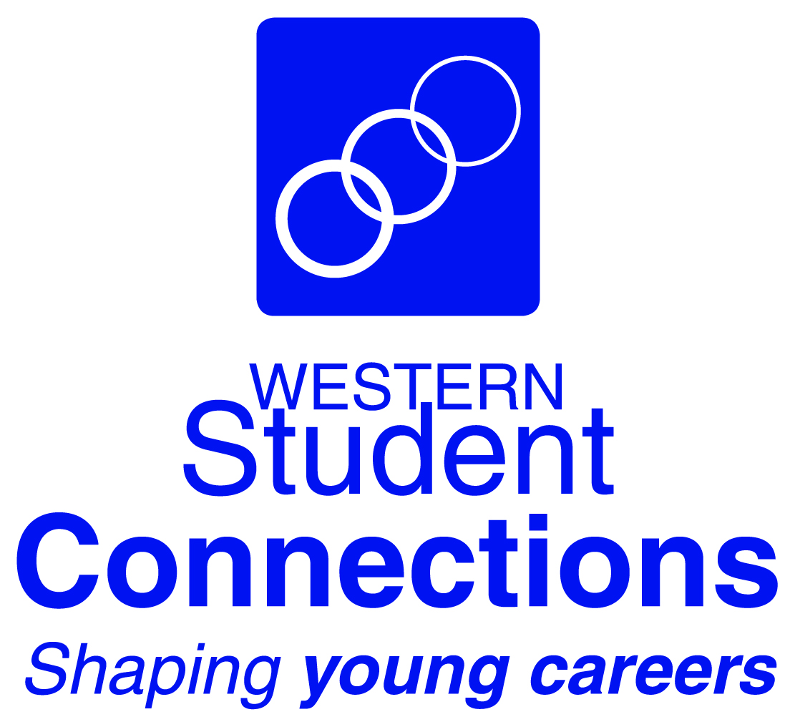
Expression of Interest
Information Technology / Business Services Work Placement
Appiwork Program

Western Student Connections is hosting What YOUth Can Do Festival of Skills, showcasing the skills and talents of young people in Western NSW. It will be held in Dubbo from Monday 21st October to Saturday 26th October 2019.

This EOI is for students in Year 11 IDT and/or Business Services, and students in Year 10 who intend enrolling in either course for Year 11 2020.

Fax to: 02 6885 6144 or Email to: reception@wsc.edu.au

School Name: ___________________________________________

School Teacher Contact: ___________________________________

Contact’s Email Address: ___________________________________

School Phone No: _________________________________________

We will be nominating the following student(s) for the Appiwork 5-day work placement program which will take place in Dubbo as part of the What YOUth Can Do Festival of Skills:

Student 1:
Name: ________________________________

Year: ____________

Student Email address: ______________________________

Will the student bring their own laptop? Yes No – WSC will provide a device

Will the student require accommodation? Yes No

Student 2:
Name: ________________________________

Year: ____________

Student Email address: ______________________________

Will the student bring their own laptop? Yes No – WSC will provide a device

Will the student require accommodation? Yes No

Please Return to Western Student Connections as soon as possible

